Room 11, NAPSA complex, P.O Box 840037, Mkushi, Zambia
2017
CHILD SAFEGAURDING POLICY
Safeguarding children’s rights
WRITTEN BY ZRDF
Zambian Rainbow Development Foundation 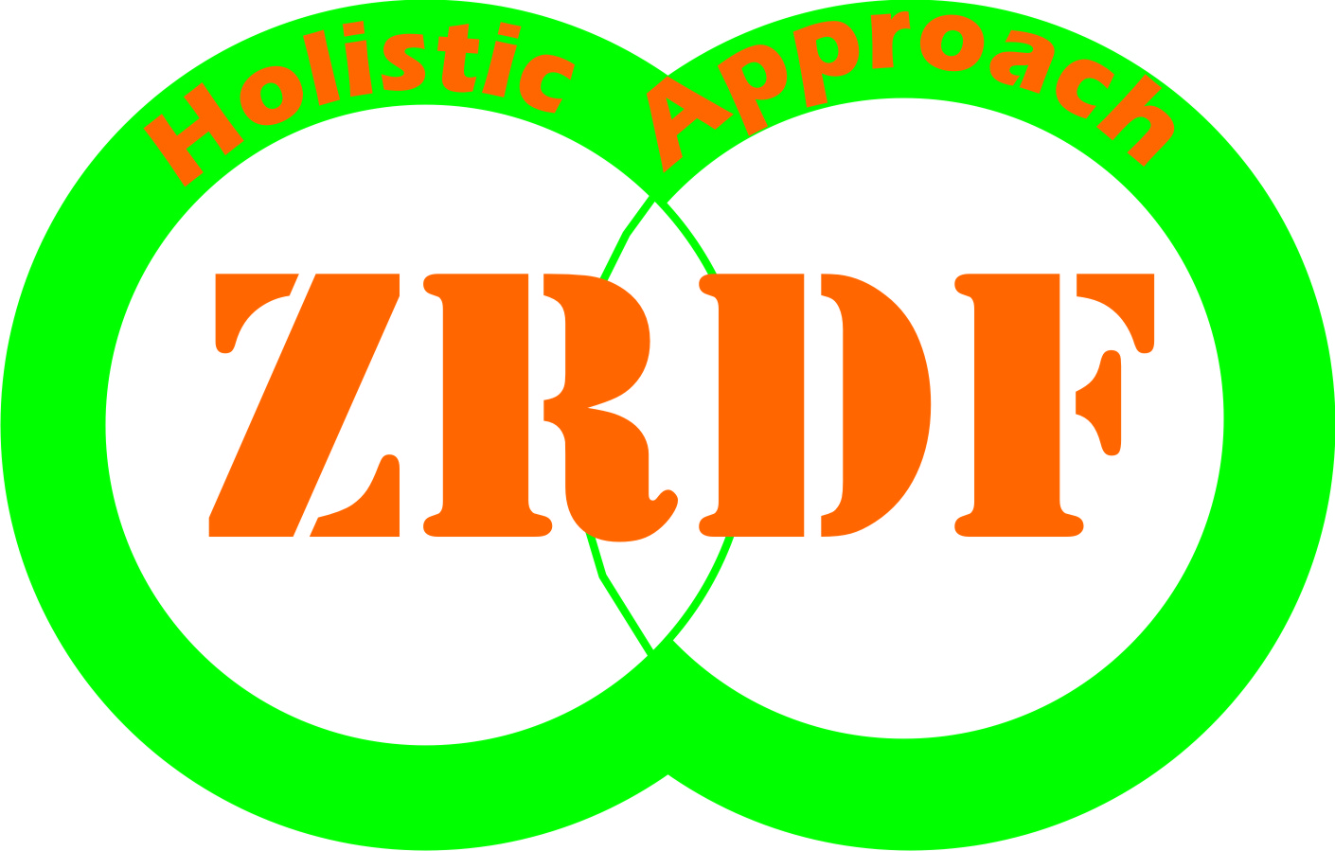
Contents
0
Foreword 2
Acknowledgment 2
Acronyms 3
SECTION ONE 4
1.0 Introduction 4
1.1 Vision statement 5
1.2 Mission statement 5
1.3 Intended users 6
1.4 Principles 6
1.5 Values 7
1.6 Vision 7
1.7 Mission Statement 7
SECTION TWO 7
2.0 Purpose 7
2.1 Risky assessments 7
2.2 Policy statement 8
2.3 Management structure and responsibilities 8
2.4 Recruitment 8
2.5 Child safeguarding training and review 8
2.6 Implementation 9
2.7 Forms of child abuse 9
2.8 Recognising of child abuse 9
2.9 Awareness raising 10
2.10 Reporting 10
2.11 Responding 11
SECTION THREE 11
3.0 Code of behaviour/conduct 11
3.1 Confidentiality and data protection 11

Foreword
Providing our children a safe environment free from harm and danger
This is the guiding principle on which this Policy is anchored.
Zambian Rainbow Development Foundation (ZRDF) recognizes that no child is safe from abuse and everyone is a potential abuser of the quality of children’s rights and expected child development. Children must be respected as young citizens with a valued contribution to make now and in future. Children must be supported by family, school and the wider society to enjoy a fulfilling childhood that enables them to realize their full potential. All forms of child abuse must and will be never tolerated by our organization. This Policy is intended to ensure effective coordination amongst all staff from Zambian Rainbow Development Foundation, Teachers, Parents and key stakeholders working with Zambian Rainbow Development Foundation (ZRDF) for the protection and development of the children of the communities we serve.
It does not only address the protection in terms of rights and obligations, but also general care and provision of the basic needs of the children.
The policy is based on pieces of legislatures that enshrines children’s rights and punitive measure to the ‘would be’ culprits or perpetrators of child abuse in any form.

ZRDF Board Chairperson
Mr Colin Williams
Lusaka

Acknowledgment
Zambian Rainbow Development Foundation would like to express their appreciation to all who have contributed to writing of this policy and to the process behind the drafting of this document. We would like to thank SAVE the children the organization which taught us how to write a policy. Lastly but the least we sincere gratitude goes to Baynards Zambia trust (BZT) for their significant financial support for the publication of this document and everyone who has added valuable and substantial insights to the development of this policy.

Acronyms
BZT-Baynards Zambia Trust
CBOs- Community Based Organizations
NHCs- Neighborhood Health Committes
NW-Neighborhood Watch
PACRA- Patents and Companies Registration Authority
PTA-Parents Teachers Association
ZRDF-Zambian Rainbow Development Foundation

SECTION ONE

1.0 Introduction
Zambian Rainbow Development Foundation (ZRDF) is a non-profit making organization registered in 2013 with the Non-Governmental Organizations Act and PACRA.
ZRDF existed as a project under a previous NGO called HODI which had been in operation since 2000. HODI was then disbanded and ZRDF continued with programs conducted within a catchment area of 2,500 square miles of Mkushi and Luano districts situated in central province of Zambia.

1.1 Vision statement
Zambian Rainbow Development foundation aims to have an empowered community freely pursuing its livelihood long term goals of having poverty free communities through demand driven initiatives.

1.2 Mission statement
ZRDF provides practical and sustainable livelihoods improvement interventions that promote quality of life to poor and vulnerable communities by working through community based structures in livelihood strengthening, women’s economic empowerment, infrastructure development, water and sanitation services provided at school, education support and integrated health services through building capacities of vulnerable households and individuals. ZRDF promotes relevant initiatives that make a difference to people’s lives through the emphasis of community led and community owned development utilising participatory approaches in all its interventions. This is categorized through four key thematic areas;
- Livelihood and food security strengthening
- Household Economic Empowerment
- Education, Water and Sanitation
- Integrated Health focusing on HIV Prevention Services
Why having a child protection policy?
- Children are among the most important stakeholders in our organisation; and this is because they are among the most vulnerable population in the communities which need special attention in order to safeguard and respect their human rights.
- The organisation regard children as equal stakeholders in the programs of the organisation therefore incorporating their rights is very important
- The organisation has realised the importance of mitigating the risks children are exposed to which can have an impact on children’s rights which are not enshrined in other human rights programs.
- Guarantee that valuing and supporting the rights of children becomes part of the organisations culture and offer members staff guidance in relation to problems that may influence children’s rights.
- the organisation believes that the development of a child is enhanced if their rights are respected and supported
Zambian rainbow development foundation is committed to practice a policy which protects children from any form of abuse. Members of staff and stakeholders are committed to safeguard the rights of children by protecting them. We will attempt to safeguard children by;
- Partaking information about child protection, and good practice with children, staff, parents and other stakeholders
- sharing information about concerns with government ministries, involving parents, members of staff as well as other concerned stakeholders
- procedures of recruitment shall be followed carefully as well as the selection of members of staff
- supervision, support and training will be provided to the members of staff and stakeholders for effective management of the policy
- the organization will be reviewing the policy every after 3yrs in order for the policy to withstand the test of time

1.3 Intended users
- Members of staff
- children
- parents
- CBOs
- PTAs
- other concerned stakeholders

1.4 Principles
- as an organization all forms of child abuse will be treated as a matter of emergency and concern
- any concerns that cannot be handled by the organization can be immediately referred to specialized institutions/authorities
- this policy shall be safeguarded and respected by all members of staff, parents children, donors as well other cooperating partners

1.5 Values
- Accountability
- Transparency
- Participation
- Integrity
- Empowerment
- Sustainability

1.6 Vision
ZRDF envisions a community free from any form of child abuse

1.7 Mission Statement
To provide practical and sustainable child safeguarding solutions that promote children’s rights through working with community based structures such as CBOs, PTAs, NHCs, NW and all other relevant institutions thereby creating an enabling environment for proper child development

SECTION TWO

2.0 Purpose
- The purpose of this policy is to safeguard and protect children’s rights
- to ensure all members of staff of ZRDF and all stakeholders respect children’s rights

2.1 Risky assessments
Members of Staff, parents, teachers, children, and other stakeholders will ensure to;
- model the way which we would want others to follow
- Promote the use of appropriate language with children.
- Desist from sexually provocative activities
- Respect a young person’s right to privacy
- Spending excessive amount of time with children away from others will not be entertained by the organisation
- Inappropriate touching of any kind to a child shall not be allowed
- On no occasion draw any conclusions about others without investigating the facts

2.2 Policy statement
As an organisation we recognise the pieces of legislature on children’s rights. Therefore, the organisation will ensure that children’s rights are safeguarded by all service providers as outlined in this policy. All Conflicts of interest shall be addressed and mitigated according to the law. This policy shall also recognise the importance of all stakeholders in upholding children’s rights. ZRDF management will raise awareness on child protection by mainstreaming children’s rights in all its programs.

2.3 Management structure and responsibilities
Director
- Ensure child safeguarding policy is implemented
- Enforce code of conduct and monitor adherence to it
- Oversee the implementation of the child safeguarding policy and regulary monitor implementation

Program officer (Focal point person)
- Overall coordinator of safeguarding developments
- Providing induction to all new staff
- Raise awareness to the key stakeholders about the importance of the policy
Other key stakeholders
- Be aware of abuse and risks to children
- Become familiar with the child safeguarding policy
- Prevent all forms of abuse of children in the community

2.4 Recruitment
ZRDF will follow the laid down procedure of staff recruitment and engagement of interns, volunteers and consultants as stipulated in the HR manual (see annex X)

2.5 Child safeguarding training and review
All members of staff responsible for safeguarding children’s rights must receive training every year and when need arise on the importance of children’s rights protection.

2.6 Implementation
Action | Responsible person | when | verification of activities | How to know it is successful (indicator) | when to monitor
Creation of deliberate actions for sensitisation | Focal point person(PO) | 2nd week of April | # of meetings  #Attendants on the register  #Of copies of minutes | Conducting monitoring visits | 1st may,2017
Building consensus meetings | Focal point person(PO) | 2nd week of July | # of meetings  #Attendants on the register  #Of copies of minutes | Conducting monitoring visits  Checking on agreed action points | 1st June, 2017
Ratification of the document by the board | Director | 3rd week of June,2017 | Board minutes | Endorsement of the policy by the board | 4th week of june,2017

2.7 Forms of child abuse
- Physical abuse
- Sexual abuse
- Child sexual exploitation
- Neglect and negligent treatment
- Emotional abuse
- Commercial exploitation
- Internet abuse
- Abusive images of children
- Spiritual abuse
- Abuse of trust

2.8 Recognising of child abuse
- Loneliness/isolation
- Self-inflicted injuries
- Aggressiveness
- Low self esteem
- Mental disturbance
- Absent minded
- Loss of appetite
- Etc.

2.9 Awareness raising
ZRDF management will raise awareness on child protection by mainstreaming children’s rights in all its programs through trainings all stakeholders and community awareness campaigns

2.10 Reporting
In a situation where a complaint is reported or a member of staff is concerned, a file shall be opened with the following details captured;
Name of the person
Age
Date of birth (if available)
Home address(if available)
Name and address of the guardian
Telephone/cell numbers( if available)

In addition, in the situation were a person is making their own complaint/concern, or on behalf of others the following details will be captured by filling in the following form;
What has provoked the concern?
Date and time when the incident happened
Was the victim (child) spoken to?
If yes what was the statement…………….
Record the details of the abuser (if known)
Designated person or organisation to take appropriate action e.g. director, social welfare
Was everyone consulted?

2.11 Responding
- The organisation shall respond to the concerned individuals immediately after the investigations have been concluded and the way forward on their allegations and concerns
- In the case were the allegation is against a staff member disciplinary actions will apply as outlined in the HR manual
- In the case were the allegations are false or invented the reporting officer will be charged with defamation of character

SECTION THREE

3.0 Code of behaviour/conduct
Members of Staff, parents, teachers, children, and other stakeholders will ensure to;
- perfect the way which we would want others to follow by making sure that inappropriate behaviour is not tolerated by all stakeholders
- Appropriate language is used when talking and interacting with children
- Abstain from sexually provocative activities when an individual is in contact with children
- right to privacy for the children will be upheld in all scenarios
- Spending excessive amount of time with children away from others will not be entertained by the organisation
- Inappropriate touching of any kind to a child shall not be allowed
- On no occasion draw any conclusions about others without investigating the fact

3.1 Confidentiality and data protection
- confidential notes/information/records shall be kept in separate files in a lockable cabinet and only designated persons will have access to the documents

Sign off

Director……………………………………………..

Board of trustees chairperson………………………..

Donor……………………………………………………

Children representative………………………………….

ANNEX ( to be attached)
HR manual
Code of conduct
Reporting procedure
Operation guidelines

